Pull base httpd image and create custom container from image

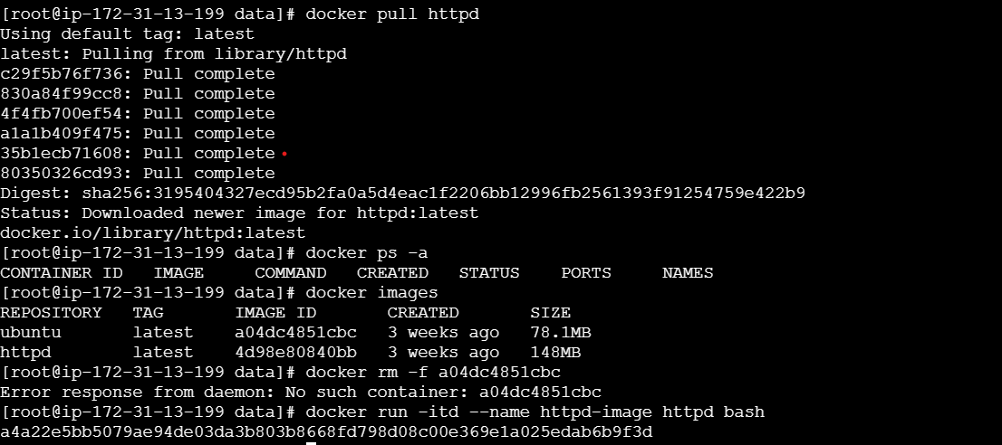



**Create own image from running container**

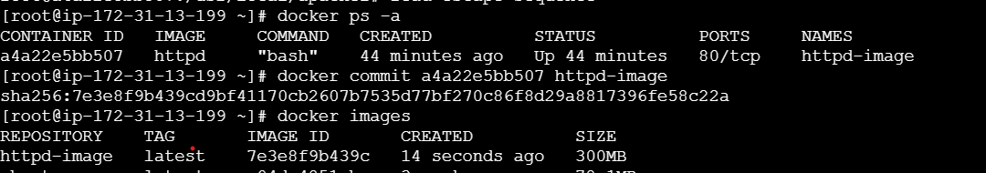

Create container from image and check all packages are install or not

